Title of the contribution

Jane Doe^{1*}, Max Mustermann¹, Jana Modaal², Jozko Mrkvicka³, Pinco Pallino⁴

¹Fantasia Faculty, Graffiti University Rome, Piazza de Pizza 12, 83621 Rome – (jane.d / max.m)@ uniroma.edu
²Department of Street Art Engineering, University College Istanbul, Hope Street 4, 9283 Istanbul – Jana.Modaal@istanbuluni.ac.tr
³German Institute for ancient graffiti, TU Berlin, Bertha-Zuckerhandl-Weg 54, 10115 Berlin – jozko.mrkvicka@TUB.ac.de
⁴Department of modern cave paintings, Museum of Modern Arts, Karoline-Tintner-Promenade 65, 10001 New York –p.p@moma.edu

*Corresponding Author

ABSTRACT:

The abstract should have a maximum of 500 words. After a brief introduction of the topic, the text should highlight the key points of the contribution. The abstract should be clear, concise, and written in English with correct spelling and good sentence structure. The abstract does not include reference citations, and all abbreviations should be explained. One figure (cf. Figure 1) can be inserted below the written abstract. The abstract submission deadline is 31 March 2023.

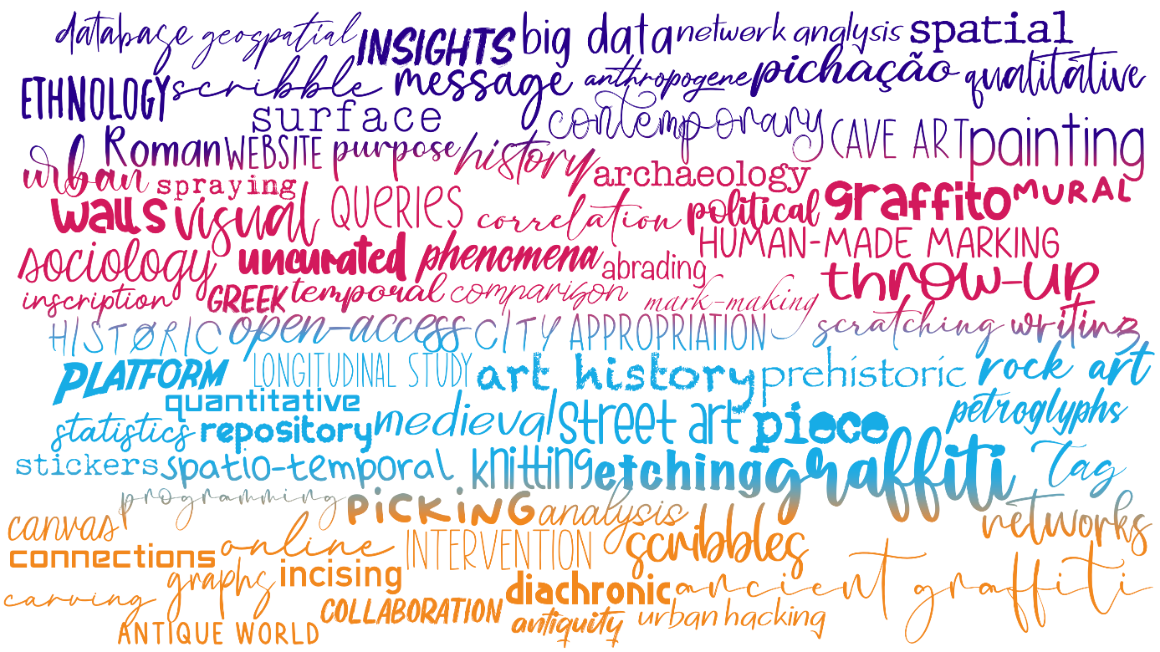

Figure 1. This is an example figure. Please make sure that the image is of sufficient quality.

