Paper template by UC/ AP2 scientific association and open access academic publisher.
Type of the Paper (Article, Essay, Review)
Title of the Manuscript in Title Case

Name Lastname ^{1,}*, Name Lastname ² and Name Lastname ³
¹ Department, Institution, Zipcode City, Country; E-Mail: author1@email.com
² Department, Institution, Zipcode City, Country; E-Mails: author2@email.com
³ Department, Institution, Zipcode City, Country; E-Mails: author2@email.com
* Corresponding author

Abstract
Title - Concise and informative. Titles are often used in information-retrieval systems. Avoid abbreviations and formulae where possible.

Author names and affiliations - Where the family name may be ambiguous (e.g., a double name), please indicate this clearly. Present the authors' affiliation addresses (where the actual work was done) below the names. Indicate all affiliations with a lower-case superscript letter immediately after the author's name and in front of the appropriate address. Provide the full postal address of each affiliation, including the country name and, if available, the e-mail address of each author.

Abstract - Pertinent overview of the work, with a maximum of 250 words. A concise and factual abstract is required. The abstract should state briefly the purpose of the research, the principal results and major conclusions. An abstract is often presented separately from the article, so it must be able to stand alone. For this reason, References should be avoided, but if essential, then cite the author(s) and year(s). Also, non-standard or uncommon abbreviations should be avoided, but if essential they must be defined at their first mention in the abstract itself.

Keywords
keyword1; keyword2; keyword3; keyword4; keyword5; keyword6. Provide a maximum of 6 keywords, using either British or American spelling, but be consistent, and avoiding general and plural terms and multiple concepts (avoid, for example, "and", "of"). Be sparing with abbreviations: only abbreviations firmly established in the field may be eligible. These keywords will be used for indexing purposes.

1. Introduction
The first heading is usually “1. Introduction” and the last one “#. Conclusions”. Headings are numbered, in title case, and in the following format:

1. This Is a Heading (Boldface)
1.1. This Is a Sub-Heading (Regular)
1.1.1. This Is a Second Sub-Heading (Regular)
The sections “Acknowledgements”, “Conflict of Interests”, “References” and “About the Author(s)” are non-numbered.

2. Referencing Style
Articles shall be submitted using the APA reference style, 6th edition. Attention: APA style requires both in‐text citations (e.g., Smith, 2016) and a final references list, so for every in‐text citation there must be a full citation in the reference list, and vice versa. All citations in the text should refer to Single author, the author's name (without initials, unless there is ambiguity) and the year of publication.

Two authors, both authors' names and the year of publication. Three or more authors: first author's name followed by 'et al.' and the year of publication. Citations may be made directly (or parenthetically). Groups of references should be listed first alphabetically, then chronologically. Examples: "as demonstrated (Allan, 1996a, 1996b, 1999; Allan and Jones, 1995). Kramer et al. (2000) have recently shown".

3. Epigraphs, Footnotes, Dashes, Hyphens, Quotation Marks, and Block Quotations
3.1. Epigraphs and Footnotes
Please limit as much as possible the usage of epigraphs and footnotes. Footnotes should be used sparingly. Number them consecutively throughout the article, using superscript Arabic numbers. Indicate the position of footnotes in the text and present the footnotes themselves separately at the end of the article.

3.2. Dashes and Hyphens
Use hyphens (-) to indicate a word connection (e.g., well-known), en-dashes (–) to indicate a period or range (e.g., 2012–2014) or “conceptual” range (e.g., Israeli–Palestinian conflict), and em-dashes (—) to indicate a break in thought or interpretation (e.g., All explorers want to discover the unknown—some even get there—but it is easier said than done). There is no space before and after the dash or hyphen.

3.3. Quotation Marks
Use single quotation marks (‘ ’) when writing concepts and terms, and double quotation marks (“ ”) when quoting directly an author; or vice-versa (i.e., double quotation marks for concepts and single for quotes). Either way, the usage of quotation marks shall be consistent throughout the article.

3.4. Block Quotations
Quotations of 40 words or more shall be structured as block quotes, for example:
Lorem ipsum dolor sit amet, consectetur adipiscing elit. Maecenas euismod laoreet consectetur. Ut aliquam consequat nibh sagittis posuere. Aenean laoreet ac massa sed congue. Suspendisse ornare in metus nec fringilla. Curabitur tristique mi non quam vulputate, sed luctus nibh bibendum. Suspendisse interdum enim ut nulla (Adams, 2012, p. 5)

4. Tables
Tables and figures must be introduced in the main text, figures can be also submitted separately (if high resolution), and we recommend to be limited to a combined total of 15. Tables and figures must be numbered, an explanatory title must be added and a caption for each table and figure must also be placed in the main text, for example (see Figure 2).
Each Figure should be supplied in a suitable size for printing as a single object, and tables should be inserted using the ‘Insert Table’ function provided by the software (do not copy paste html or use tables on image format).

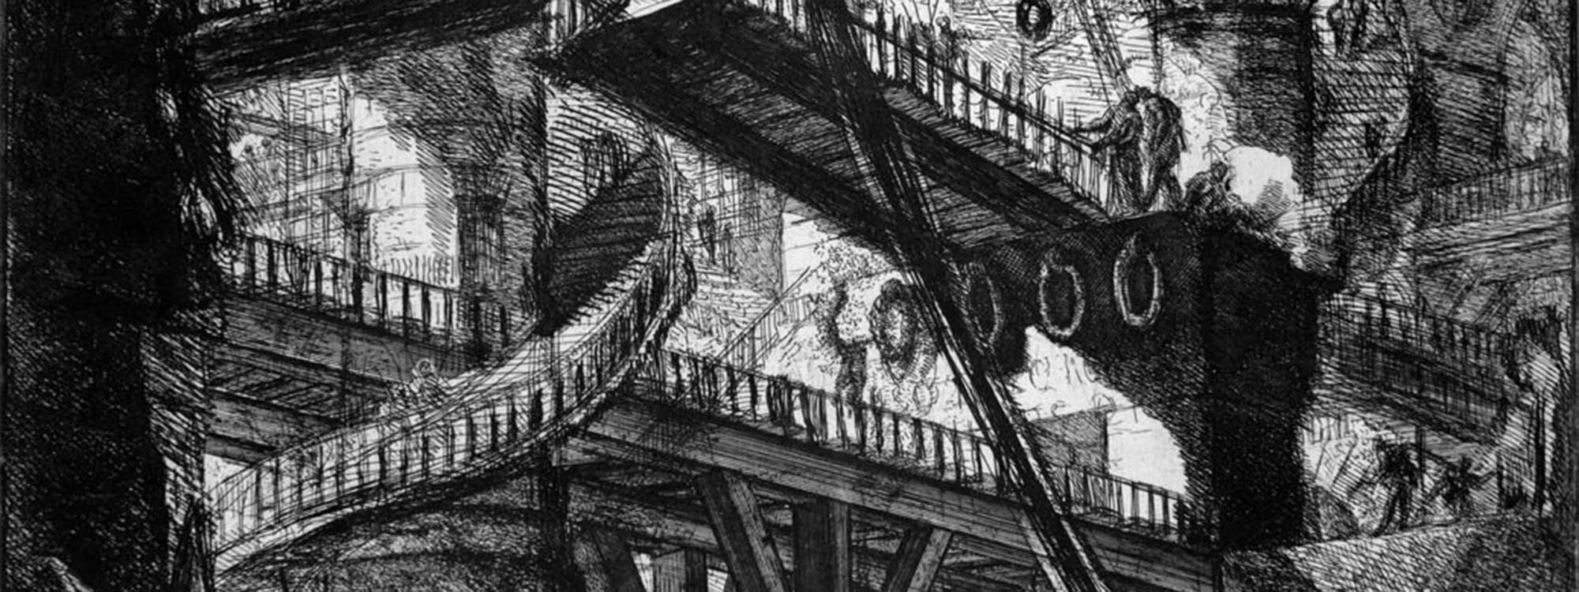
Figure 1. Title of the figure here in sentence case. Source: Always include the source if retrieved from another work and guarantee that you have the permission to reuse the figure. TIFF or JPEG: Color or grayscale photographs (halftones), keep to a minimum of 200 dpi (if needed attached or in shared folder link).
Example | Example1
1 | Example1
2 | Example1
3 | Example1

Table 1. Title of the table in sentence case.

5. Conclusions
The main conclusions of the study may be presented in a short Conclusions section, which may stand alone or form a subsection of a Discussion or Results and Discussion section.

Conflict of Interests
State any potential conflicts of interest here or add the sentence “The authors declare no conflict of interests”.

Acknowledgements
Collate acknowledgements in a separate section at the end of the article before the references and do not, therefore, include them on the title page, as a footnote to the title or otherwise. List here those individuals who provided help during the research (e.g., providing language help, writing assistance or proof reading the article, etc.).

References
Articles shall be submitted using the APA reference style, 6th edition. Journal titles should be spelled out in full. Personal communications should be cited as such in the text and should not be included in the reference list. Please note the following examples:

Reference to a journal article: Anselin, L., Varga, A., Acs, Z., 1997. Local geographic spillovers between university and high technology innovations, Journal of Urban Economics 42, 442-448.

Reference to a book: Marlow-Ferguson, R., Lopez, C., 2001. World Education Encyclopedia: A Survey of Educational Systems Worldwide, second ed. Thomson Gale, Detroit, MI.

Reference to a chapter in an edited book: Eberts, R.W., McMillen, D.P., 1999. Agglomeration economies and urban public infrastructure, in: Cheshire, P., Mills, E. (Eds.), Handbook of Regional and Urban Economics, vol. 3, in: Applied Urban Economics, Elsevier, New York, pp.1455-1495.

Citing and listing of Web references. As a minimum, the full URL should be given. Any further information, if known (Author names, dates, reference to a source publication, etc.), should also be given.

